A000-Eur-Magna Graecia-Kybele-Seated-Terra cotta-500 BCE

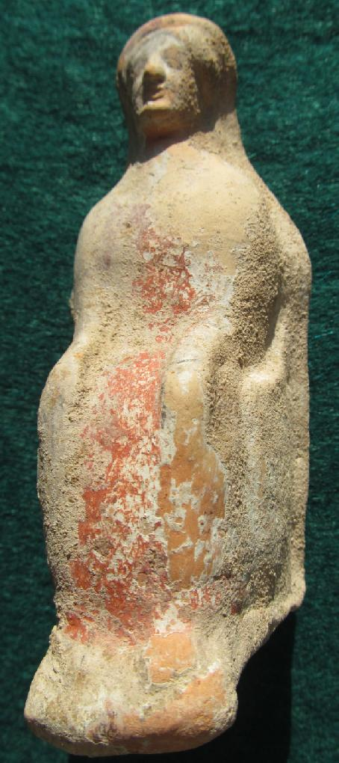 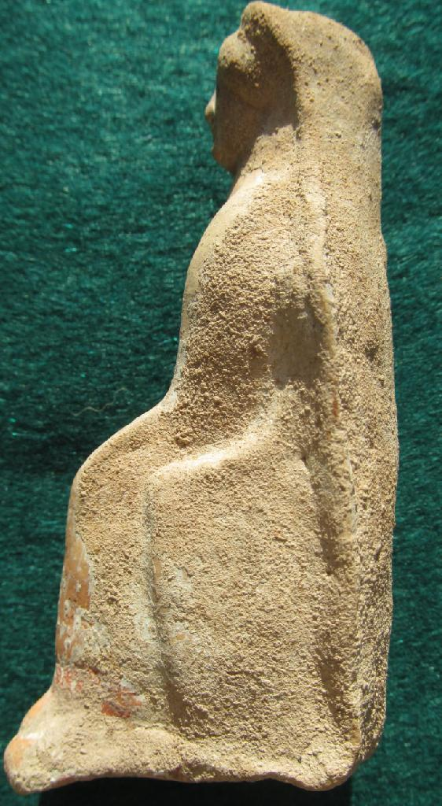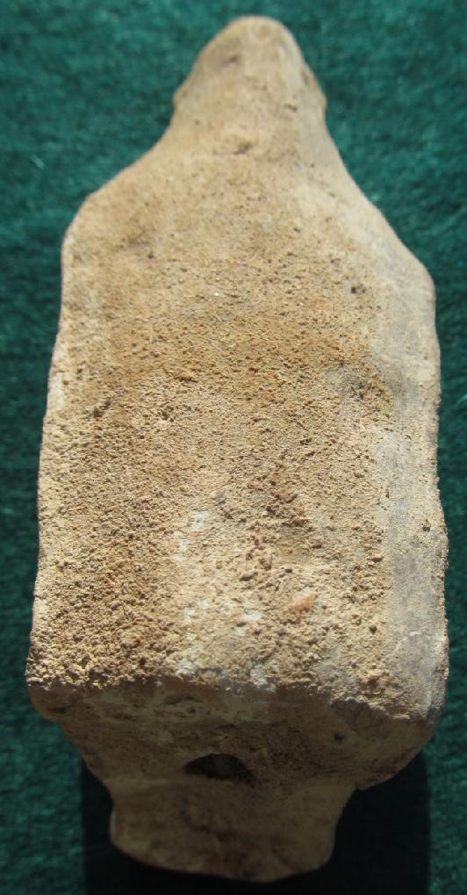 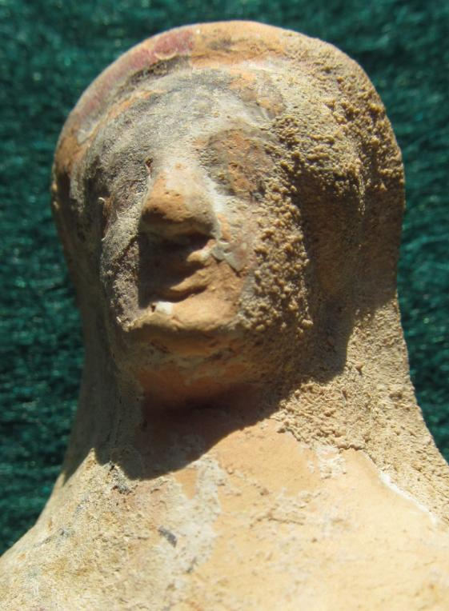

Figs. 1-4. Eur-Magna Graecia-Kybele-Seated-Terra cotta-500 BCE

Case No.: 4

Accession No.

Formal Label:

**Display Description:**

Magna Graecia, western colonies, c 500 BCE. An elegant female figure, possibly representing the goddess Kybele (Cybele), mother of the gods, sitting with impressive posture, both hands placed upon her knees. She is dressed in a fine polos and chiton, the draperies of which cascade over her seated body, and diadem upon her coiffure with curls framing her sensitively modeled face. Nice remains of red and white pigment still grace the piece.

Magna Graeca in southern Italy and Sicily became the center of a thriving Greek territory from the Gulf of Taranto southward by 800-700 BCE This statuette of Kybele, the mother of the gods, was made c 700-600 BCE before the onslaught of warring and malaria took its toll by 500 BCE. Chief cities during Magna Graeca’s heyday were Tarentum (colonized from Sparta), Metapontum (colonized from Achea), Heraclea (colonized from Tarentun), Siris (colonized from Colophon), Subaris (colonized from Achaea), Thurii (colonized from Athens) , Crotona (colonized from Achaea), Caulonia (colonized from Crotona), Neapolis (colonized from Naples), Paestum or Posidonia (colonized from Sybaris), Eldea (colonized from Chalcis), Laos (colonized from Sybaris), Hipponium (colonized from Epizypharian Locris), and Rhegium (colonized from Reggio de Calabria and Chalcis). Based on these colonization the Greek origin of this style of statuette appears to have been from the

Accession Number:

**LC Classification:** NA279.M3

Date or Time Horizon: 500 BCE

Geographical Area: Magna Graeca

**Map:**

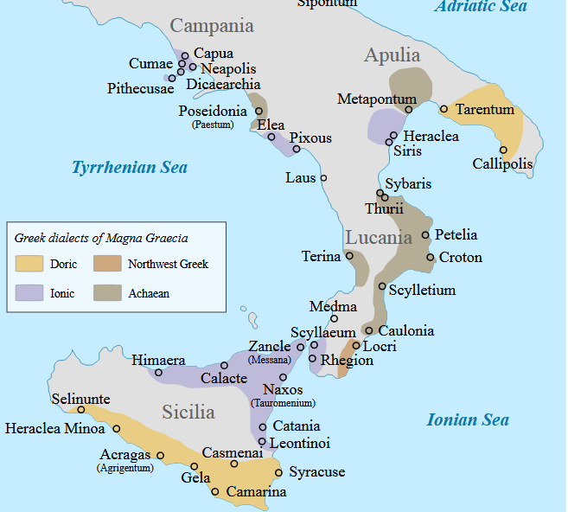

Magna Graeca cities after https://upload.wikimedia.org/wikipedia/commons/thumb/4/49/Magna_Graecia_ancient_colonies_and_dialects-en.svg/450px-Magna_Graecia_ancient_colonies_and_dialects-en.svg.png

According to Strabo (*Geographica*), Magna Graecia's colonization had already begun by the time of the Trojan War and lasted for several centuries. By the 8th c BCE Greek settlement (Cerchiai 2012:  14–18) ranged widely afield from southern Italy to the eastern and northern coasts of the Black Sea, Eastern Libya, Massalia (Marseille), and Sicily. The Ancient Greek language, its religious rites and its traditions of the independent *polis* founded an original Hellenic civilization soon developed, later interacting with the native Italic civilisations. The most important cultural transplant was the Chalcidean/Cumaean variety of the Greek alphabet, which was adopted by the Etruscans; the Old Italic alphabet subsequently evolved into the Latin alphabet, which became the most widely used alphabet in the world

**GPS coordinates:**

Cultural Affiliation:

Media:

Dimensions:

Weight:

Condition:

Provenance:

**Discussion:**

**References:**

* Adam-Veleni, Polyxeni, and Dimitra Tsangari, eds. 2015. *Greek colonisation: New data, current approaches; Proceedings of the scientific meeting held in Thessaloniki (6 February 2015).* Athens: Alpha Bank.
* Bennett, Michael J., Aaron J. Paul, Mario Iozzo, and Bruce M. White. 2002. *Magna Graecia: Greek Art From South Italy and Sicily.* Cleveland, OH: Cleveland Museum of Art.
* Casadio, Giovanni, and Patricia A. Johnston. 2009. *Mystic Cults In Magna Graecia.* Austin: University of Texas Press.
* Cerchiai, Lucia, Lorenna Jannelli, and Fausto Longo, eds. 2004. *The Greek cities of Magna Graecia and Sicily.* Photography by Mark E. Smith. Los Angeles: J. Paul Getty Museum.
* Ceserani, Giovanna. 2012. *Italy's Lost Greece: Magna Graecia and the Making of Modern Archaeology.* New York: Oxford University Press.
* Gualtieri, M. 1993. *Fourth Century B.C. Magna Graecia: A Case Study.* Jonsered, Sweden: P. Åströms.
* Holloway, R. Ross. 1978. *Art and Coinage In Magna Graecia.* Bellinzona: Edizioni arte e moneta.
* Mayo, Margaret Ellen. 1982. *The Art of South Italy: Vases From Magna Graecia.* Richmond: Virginia Museum of Fine Arts.
* Pugliese Carratelli, Giovanni. 1996. *The Greek World: Art and Civilization In Magna Graecia and Sicily.* New York: Rizzoli.
* ————, ed. 1996. *The Western Greeks: Catalog of an exhibition held in the Palazzo Grassi, Venice, March–Dec., 1996.* Milan: Bompiani.
* Zuntz, Günther. 1971. *Persephone: Three Essays On Religion and Thought In Magna Graecia.* Oxford: Clarendon Press.